Mô hình:

Model: "LeNet5"

_________________________________________________________________

Layer (type) Output Shape Param #

=================================================================

conv2d_2 (Conv2D) (None, 24, 24, 6) 156

max_pooling2d_2 (MaxPoolin (None, 12, 12, 6) 0

g2D)

conv2d_3 (Conv2D) (None, 8, 8, 16) 2416

max_pooling2d_3 (MaxPoolin (None, 4, 4, 16) 0

g2D)

flatten_1 (Flatten) (None, 256) 0

dense_3 (Dense) (None, 120) 30840

dropout_2 (Dropout) (None, 120) 0

dense_4 (Dense) (None, 84) 10164

dropout_3 (Dropout) (None, 84) 0

dense_5 (Dense) (None, 10) 850

=================================================================

Total params: 44426 (173.54 KB)

Trainable params: 44426 (173.54 KB)

Non-trainable params: 0 (0.00 Byte)

Hyperparameters:

* SGD
* Lr= 0.001
* Loss = sparse_categorical_crossentropy
* Batch size = 64

Config FL:

* 50 client
* Chọn 10 client mỗi round

Centrailized Results

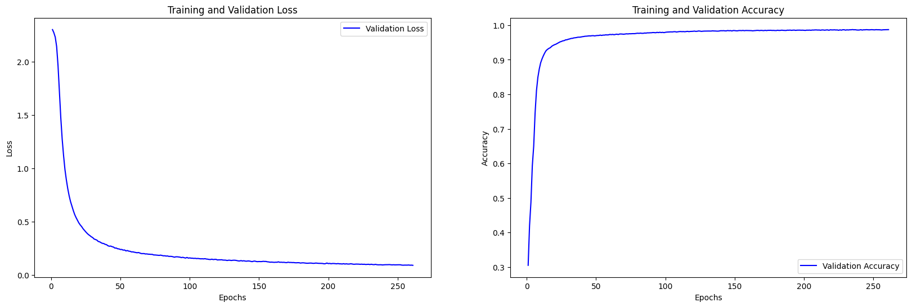

Accuracy: 0.9872

Alpha = 1

FedAvg với epoch = 1

[(0, 0.1168999969959259), (1, 0.19259999692440033), (2, 0.24539999663829803), (3, 0.20659999549388885), (4, 0.17960000038146973), (5, 0.27950000762939453), (6, 0.33079999685287476), (7, 0.275299996137619), (8, 0.4471000134944916), (9, 0.5238000154495239), (10, 0.603600025177002), (11, 0.6365000009536743), (12, 0.6190999746322632), (13, 0.6100999712944031), (14, 0.6460000276565552), (15, 0.6682000160217285), (16, 0.6873000264167786), (17, 0.6887000203132629), (18, 0.7035999894142151), (19, 0.743399977684021), (20, 0.7360000014305115), (21, 0.7634999752044678), (22, 0.7893999814987183), (23, 0.8223999738693237), (24, 0.8148000240325928), (25, 0.8184000253677368), (26, 0.8436999917030334), (27, 0.8352000117301941), (28, 0.8483999967575073), (29, 0.8641999959945679), (30, 0.8659999966621399), (31, 0.8575999736785889), (32, 0.8467000126838684), (33, 0.8536999821662903), (34, 0.8671000003814697), (35, 0.8568999767303467), (36, 0.8729000091552734), (37, 0.8745999932289124), (38, 0.8830999732017517), (39, 0.8791000247001648), (40, 0.8744000196456909), (41, 0.8877000212669373), (42, 0.8878999948501587), (43, 0.892799973487854), (44, 0.8851000070571899), (45, 0.8907999992370605), (46, 0.8916000127792358), (47, 0.8985999822616577), (48, 0.8991000056266785), (49, 0.8992000222206116), (50, 0.8998000025749207)]}

FedAvg khác epoch

[(0, 0.13930000364780426), (1, 0.2517000138759613), (2, 0.4668999910354614), (3, 0.5467000007629395), (4, 0.6586999893188477), (5, 0.722100019454956), (6, 0.7161999940872192), (7, 0.7361999750137329), (8, 0.7631000280380249), (9, 0.8101999759674072), (10, 0.8357999920845032), (11, 0.8551999926567078), (12, 0.8442999720573425), (13, 0.8263000249862671), (14, 0.8652999997138977), (15, 0.8697999715805054), (16, 0.8762999773025513), (17, 0.8673999905586243), (18, 0.8571000099182129), (19, 0.888700008392334), (20, 0.8860999941825867), (21, 0.9093999862670898), (22, 0.9100000262260437), (23, 0.9174000024795532), (24, 0.9168999791145325), (25, 0.9211999773979187), (26, 0.9273999929428101), (27, 0.9283999800682068), (28, 0.9300000071525574), (29, 0.9326000213623047), (30, 0.9327999949455261), (31, 0.9320999979972839), (32, 0.9319999814033508), (33, 0.9276999831199646), (34, 0.9316999912261963), (35, 0.9344000220298767), (36, 0.9394000172615051), (37, 0.939300000667572), (38, 0.9423999786376953), (39, 0.9409000277519226), (40, 0.9419999718666077), (41, 0.9451000094413757), (42, 0.9467999935150146), (43, 0.9469000101089478), (44, 0.9286999702453613), (45, 0.9469000101089478), (46, 0.9470000267028809), (47, 0.949400007724762), (48, 0.9490000009536743), (49, 0.9503999948501587), (50, 0.9513999819755554)]

FedImp với epoch = 1

[(0, 0.1184), (1, 0.1642), (2, 0.2019), (3, 0.2335), (4, 0.2213), (5, 0.326), (6, 0.3655), (7, 0.3245), (8, 0.3889), (9, 0.4223), (10, 0.5305), (11, 0.5795), (12, 0.5954), (13, 0.6168), (14, 0.6769), (15, 0.699), (16, 0.6886), (17, 0.6625), (18, 0.6654), (19, 0.7116), (20, 0.717), (21, 0.7675), (22, 0.7821), (23, 0.8122), (24, 0.8117), (25, 0.8027), (26, 0.8352), (27, 0.8419), (28, 0.8316), (29, 0.8593), (30, 0.8465), (31, 0.855), (32, 0.8408), (33, 0.864), (34, 0.8647), (35, 0.86), (36, 0.8738), (37, 0.8733), (38, 0.8793), (39, 0.8685), (40, 0.8735), (41, 0.8891), (42, 0.892), (43, 0.8926), (44, 0.8805), (45, 0.8944), (46, 0.8858), (47, 0.9048), (48, 0.8948), (49, 0.906), (50, 0.9007)]

FedImp khác epoch

[(0, 0.1075), (1, 0.3206), (2, 0.5322), (3, 0.6386), (4, 0.6437), (5, 0.7159), (6, 0.6896), (7, 0.7505), (8, 0.771), (9, 0.7975), (10, 0.8353), (11, 0.8635), (12, 0.8583), (13, 0.8407), (14, 0.8723), (15, 0.8795), (16, 0.8726), (17, 0.876), (18, 0.8751), (19, 0.9063), (20, 0.8975), (21, 0.9188), (22, 0.9153), (23, 0.9245), (24, 0.9261), (25, 0.9251), (26, 0.9294), (27, 0.9296), (28, 0.9319), (29, 0.9342), (30, 0.933), (31, 0.9359), (32, 0.9346), (33, 0.9357), (34, 0.939), (35, 0.9367), (36, 0.9413), (37, 0.9427), (38, 0.9441), (39, 0.9439), (40, 0.9462), (41, 0.9483), (42, 0.9475), (43, 0.9502), (44, 0.9407), (45, 0.9475), (46, 0.9484), (47, 0.953), (48, 0.9518), (49, 0.9534), (50, 0.9539)]

Proposed Algorithm

Alpha = 50

Alpha = 100